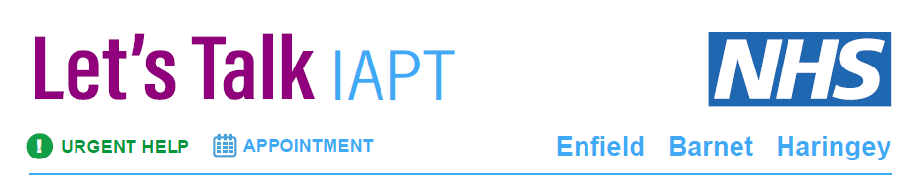

**Making a referral**

**Let’s Talk** **IAPT** is available to anyone 16 years and over and registered with a GP in Barnet, Enfield and Haringey. If you are under 16, talk to your GP to find the right service for you.

We actively encourage self-referrals but referrals can also be made by professionals, carers or patients. All we ask is that the patient is always aware of and in agreement with the referral.

If you are registered with a GP outside the areas above, you can find your local talking therapies service: [here](https://beta.nhs.uk/find-a-psychological-therapies-service/) (Hyperlink)

The service is designed to work with mild to moderate common mental illnesses, including depression and anxiety disorders. Please note that IAPT services are unable to provide therapy for people with significant issues of risk to self or others, or those with severe mental health or drug and alcohol problems

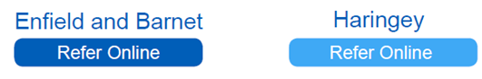

For those registered with an Enfield or Barnet GP For those registered with a Haringey GP

This will open a secure web page where you can enter your details.

We will try to contact you within two weeks of your referral; however this may not always be possible due to the large number of referrals we receive.

In line with our policy we are unable to disclose any information regarding a client’s referral without their verbal consent.

**Please note** - First assessments will be carried out by telephone unless there is a specific request for a face to face appointment.

Therapy can take place over the phone, face-to-face or online. We have therapists that speak and can offer assessments in other languages and where this is not possible interpreters are available on request.